**Welcome to Plexao S and Plexao S X**

**Plexao S X:**

**Welcome, this guide will help you setup and use Plexao S X**

**(A Plexao Account is required to use some features)**

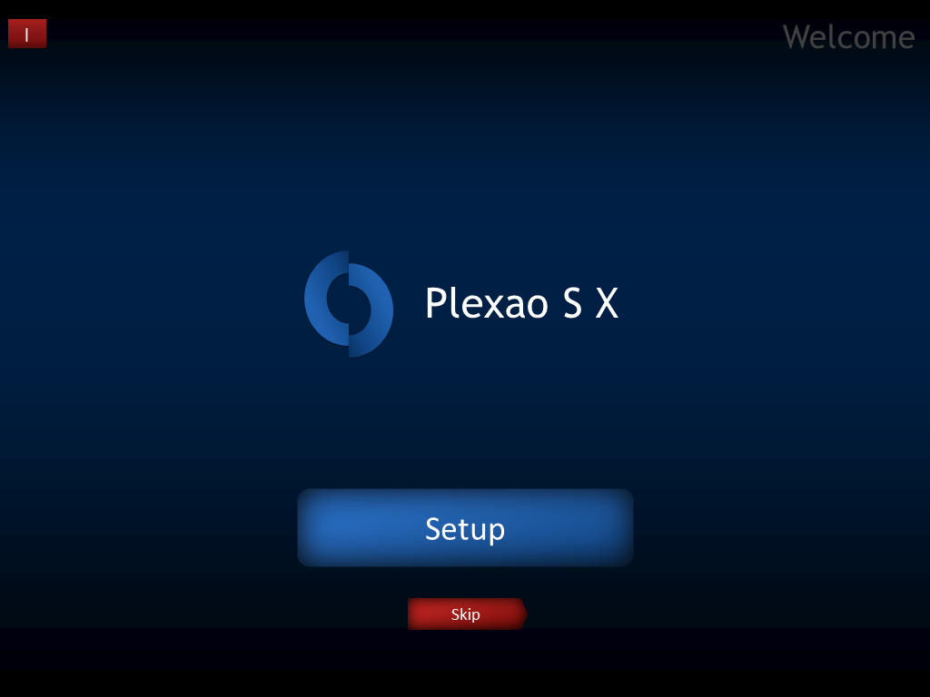

Click the Setup button to start setting up Plexao S X, click skip to skip setup or click the shutdown button on the upper left corner to leave

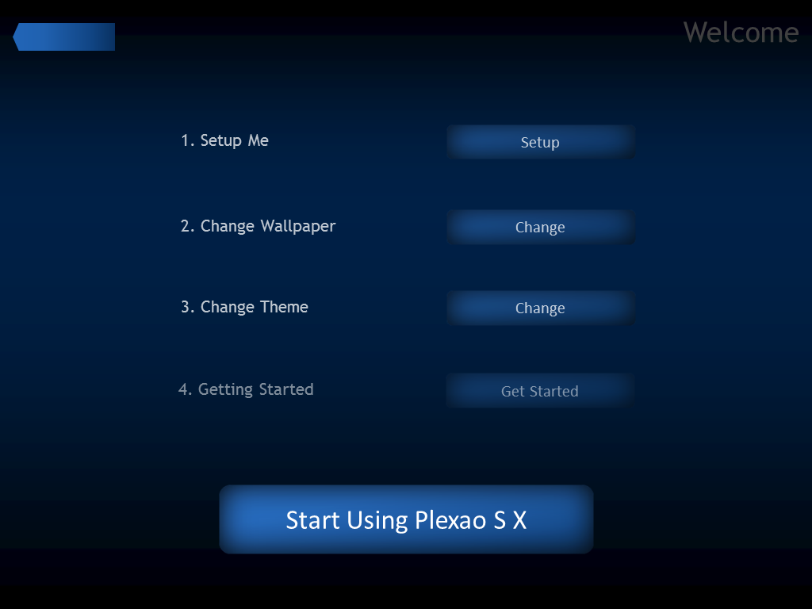

From here you can setup the Me app, change your wallpaper, change theme and access this guide. When you are finished setting up Plexao S X you can click “Start Using Plexao S X”, or click the “<” to go back

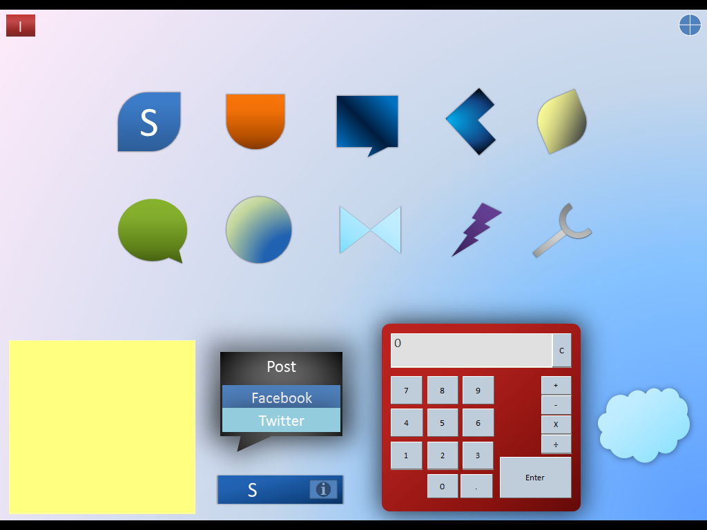

After setup you are taken to the Desktop, click an icon to launch an app, or use the widgets on the bottom. On the upper left is the Shutdown button, on the upper right there is the clock, click it to view the time

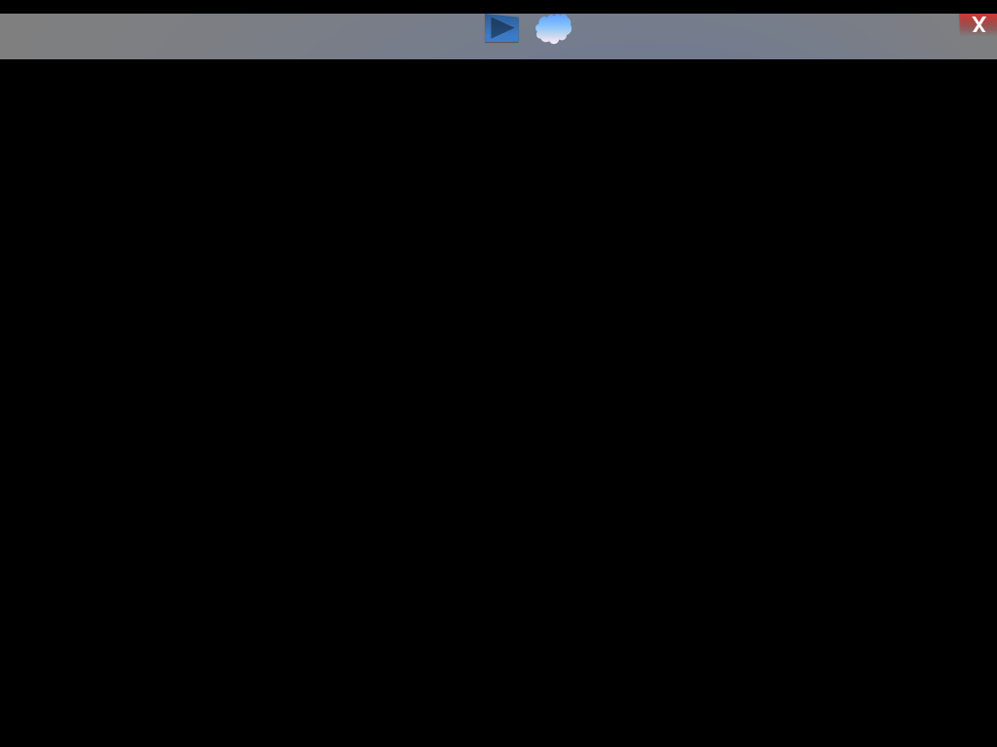

Click on the X button to close an app, click the cloud button to go to the Plexao S version of the app or click the > to reload the page (Web Apps Only)

**Plexao S:**

**Welcome, this guide will help you use Plexao S**

**(A Plexao Account is required to use some features)**

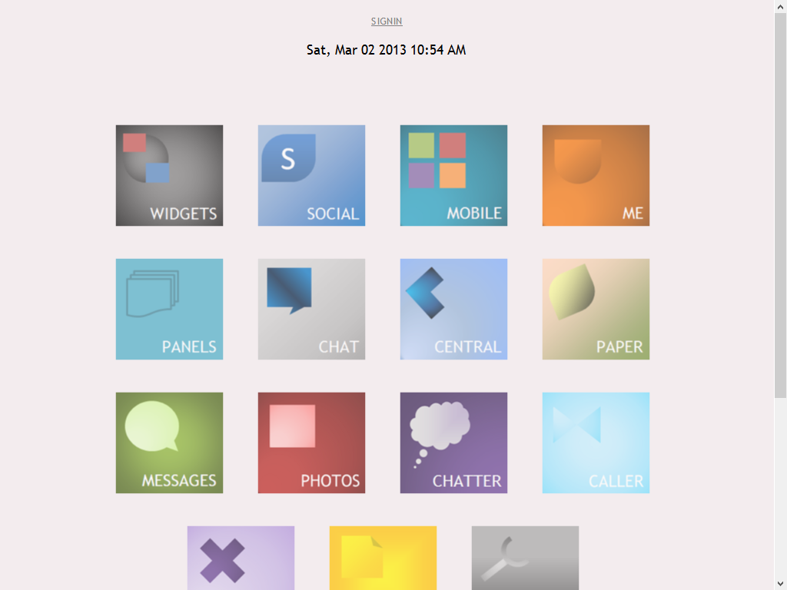

You are taken to the Desktop, click an icon to launch an app. On the top is the Sign In and time



Click on the X button to close an app